SP Analytics User Guide

|  |  |
| --- | --- |
| Primary Authors: | Nicole Roark, Patrick Tessmer |
| Contributors: | Nathan Soundappan, Alex Kwon, Matthew Murch |

**ACCEPTANCE:**

|  |  |  |
| --- | --- | --- |
| Sponsor/Client: | **Jackson Polish** | **5/7/20** |
| Team Representative: | **Colin Evans** | **5/7/20** |
| others | **Nicole Roark, Patrick Tessmer** | **5/7/20** |

**Table of Contents**

[**Preface ****Nicole Roark] 2**

**Features/Use Cases/Workflow [Patrick Tessmer]** **3**

Login

Priority 1 : Shot Chart

Priority 2 : Possession Diagram

Priority 3 : Passing Diagram

Priority 4 : Time On Ice

**Support [Nicole Roark]** **7**

Points of Contact

Additional Support

**Glossary [Nicole Roark]** **8**

## Preface Nicole Roark

**Introduction**:

SPAnalytics is an application founded by our client Jackson Polish. It aims to record accurate and detailed hockey game data in real time or through recorded games and using those data it will generate analytical functions that output meaningful player and team statistics for hockey teams using this application.

There are 4 main features of this application. The first feature is the shot chart which records different types of shots taken during the game. The second feature is the possession diagram which allows live coverage of who has possession of the puck. The third feature is the passing diagram which records the different types of passes occuring during the game. The fourth feature is the time on ice diagram which keeps track of an individual player’s total time on ice.

**Purpose**:

As of right now this software is mildly complicated to set up on your machine the first time you wish to run it, so this document will help walk you through how to login and get the features running. It will also give you a brief tutorial for each feature as to how it is intended to be used.

**Audience**:

Currently the only spectators to our project and its development are the client Jackson Polish, our instructor Professor Stahr, and the developers. After the project has undergone phase three of development, it will be ready to be tested on the market.

## Features/Use Cases/Workflow Patrick Tessmer

### Login

The project is currently only available to admins. To log in to the project first click submit on the initial page. This will take some time, so it is normal to have to wait a moment for it to check your key. Then select admin from the dropdown and click login. This will bring up a prompt for a password. The password for admin is test.

### Priority 1: Shot Chart

Provides a shot chart and heat map of the shots that players have taken in a game.

Dropdown variables to track game details:

* Team for
* Team against
* Player
* Goalie
* Shot number
* Status
* Release type
* Play type
* Shot type
* Primary chance
* Secondary chance
* Extra info,
* RB
* Player status
* Play created by
* Scoring chance
* Result

These are selected from drop down menus. This information needs to be collected and stored in a database so detailed analysis can be done in future phases of the project. Data storage needs to occur by clicking the “Save All’’ button. (Unfinished)

Rink & Net Diagram:

1. Select Shot type drop down and pick a type of shot to insert in either the Rink or Net Diagrams.
2. Once selected, click on either Rink or Net.
3. Circular shots should be placed where mouse click occured.
   1. Red - failed shot on target.
   2. Green - successful goal on target.
   3. Black - missed shot.
   4. Number - keeps track of each shot in the game (i.e. 1 is first shot of the game, 5 is fifth shot of the game etc.)

Currently, each goal coordinates are outputted to the Eclipse Console. What is left for the next phase should collect these outputs and store it in the database.

(see glossary - figure 1).

Heat Map:

1. Click the “Heat Map” checkbox to show heat map view of net for shots that were aimed at the net
2. Only goals or no goals on target are shown the heat map
3. Colors reflect the concentration of shots taken in the rink and the net
4. Uncheck the “Heat Map” checkbox to move back to the default net chart view

(see glossary - figure 2).

### Priority 2: Possession Diagram

The possession diagram lets you keep track of the possession changes during the duration of a game.

Upon opening this page

1. Select a game from the dropdown menu
2. Select which team is on offense and which on defence in each area of the rink
3. Choose a player
4. Start the clock

To indicate a change in possession

1. Select one of the 6 buttons on the ice
2. view the change in possession that has occured in the table

To use clock

1. Use the next period button to change the period where the possession change is recorded.
2. Use stop to pause the clock
3. Use reset to reset the clock to 20 minutes.

(see glossary - figure 3)

### Priority 3: Passing Diagram

Upon opening this page

1. Select from the ‘Games’ dropdown which game you wish to track data for
2. Select from the ‘Possession’ dropdown which team acquires possession of the puck first
   1. This is how we track whether a turnover is a turn or a take as well as which team is making which pass

Adding a pass to the rink

1. Select from the ‘Pass Type’ dropdown what sort of pass it is
   1. Complete, Incomplete, Turnover, Successful Clear, Unsuccessful Clear, or Hit
2. Click on the rink where the pass originated (this will be marked with an open circle)
3. Click on the rink where the pass ends/the puck destination (this will be marked with a closed circle)
   1. If the pass type is ‘Hit’ you will not need a secondary location
   2. Each different type of pass is associated with its own color to help visually understand what is going on
      1. Green, red, yellow, blue, orange, and black
4. There will be a line connecting the pass’ origin to its destination to help visually make the diagram more readable

Populating the Table

1. The only information that is not directly pulled from this page is the player #
   1. This should pull from the Time On Ice and Possession Diagram pages
   2. If this does not work, we will add a ‘Player #’ dropdown and you will select the player # before adding the pass to the rink
2. The other values the table will track will be the Period, Time Stamp, and Team
   1. This is why it is important to select the team with initial possession from the ‘Possession’ dropdown at the beginning of each period

### Priority 4: Time on Ice

### Moving players from the bench to the lineup

### Select a number on the bench

1. Click a spot on the line up

Moving players from the line up to the bench

1. Option 1:
   1. Select a jersey
   2. Choose a player on the line up by clicking their number
2. Option 2:
   1. Hit 2, 3, 4, or 5 on the keyboard
   2. Select that number of jerseys to swap out
   3. Click the players on the line up to switch to those position (The players from the lineup will be moved to the ice positions in the order the ice positions were clicked)

Swapping players on the Ice

1. Click the checkbox labeled “swap”
2. Click a jersey
3. Click another jersey you want to swap

Swapping players within the lineup

1. Click on a player in the line up (It will highlight red, indicating you can change the line up)
2. Click on another player to swap their positions in the line up

## Support Nicole Roark

### Points of Contact:

If at any point during this guide or using the software you encounter a problem or error you are unable to solve, please do not hesitate to reach out to our client Jackson Polish, instructor Lynn Stahr, or our team lead Colin Evans.

Jackson Polish Colin Evans Lynn Stahr  
(440) 409 - 6872 (614) 425 - 4897 BEN018  
[polishjt@miamioh.edu](mailto:polishjt@miamioh.edu) [evansct@miamioh.edu](mailto:evansct@miamioh.edu) [stahrlc@miamioh.edu](mailto:stahrlc@miamioh.edu)

### Additional Support:

Additionally, if you are a developer for phase three of this project and you run into a problem during the 2020-2021 academic year, please do not hesitate to reach out to Nicole Roark or Matthew Murch. They are developers from phase two but will still be in the Oxford area and would love to meet with you.

Nicole Roark Matthew Murch  
(513) 264 - 3406 (614) 824 - 9375  
[roarknr@miamioh.edu](mailto:roarknr@miamioh.edu) [murchmc@miamioh.edu](mailto:murchmc@miamioh.edu)

## Glossary Nicole Roark

**[1] Shot Chart - Rink View**

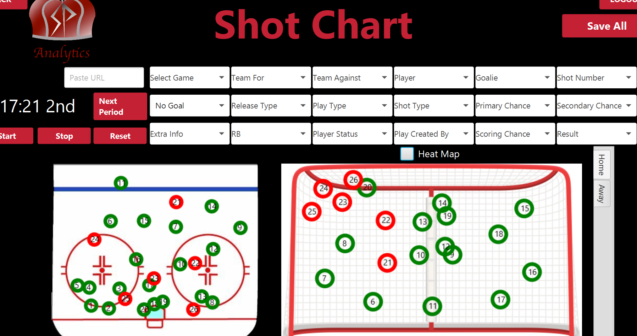

**[2] Shot Chart - Heat Map View**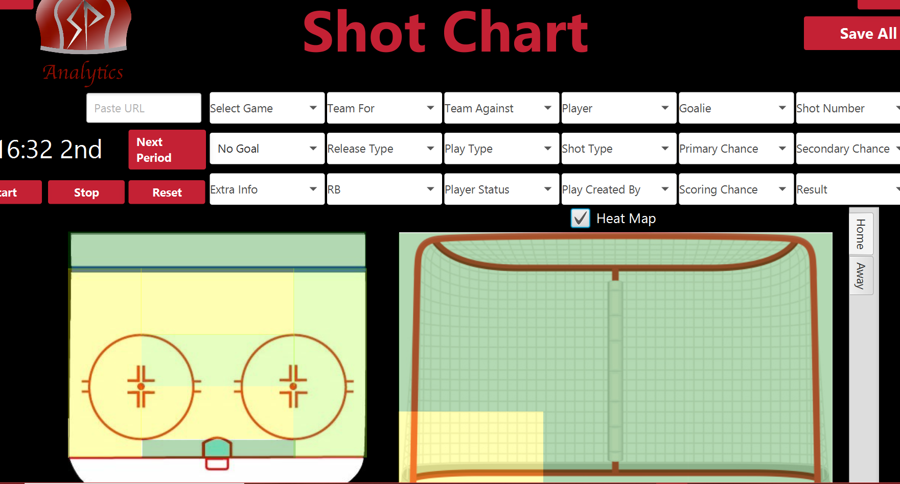

**[3] Possession Diagram**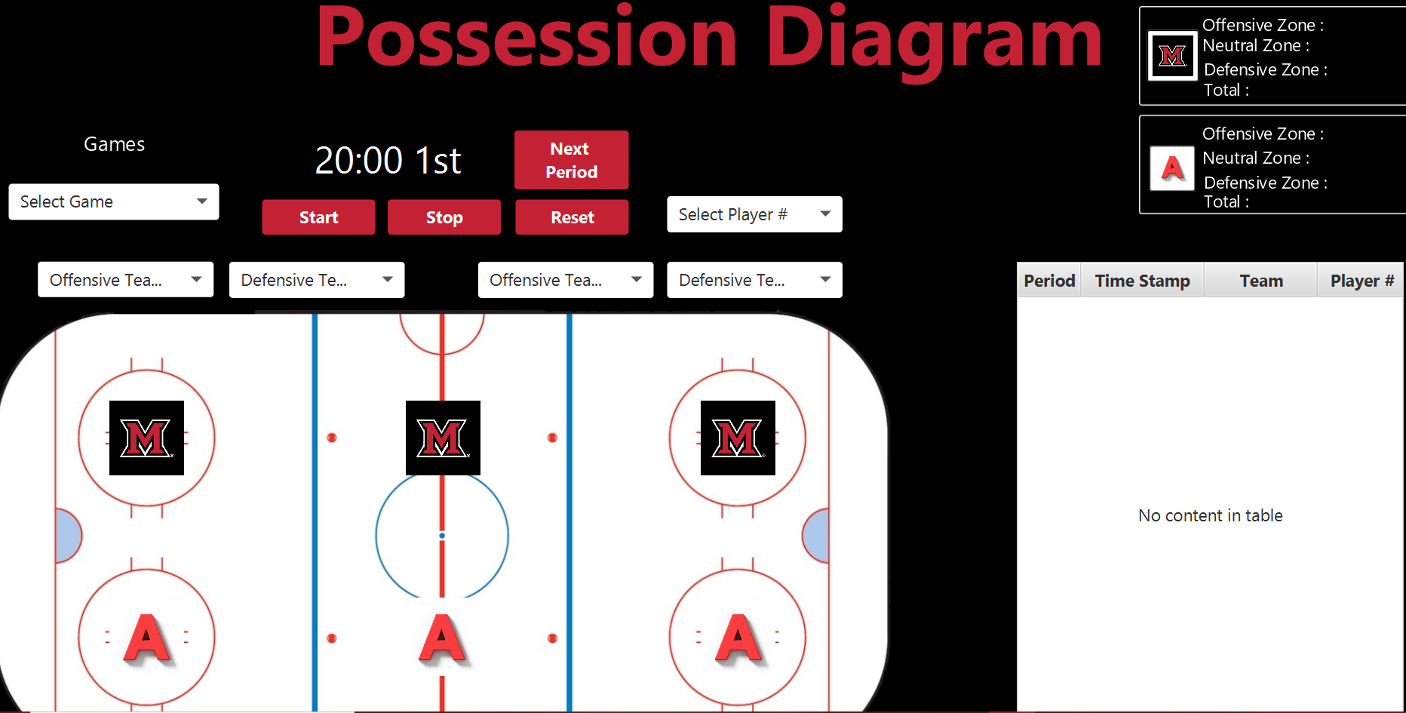

**[4] Passing Diagram**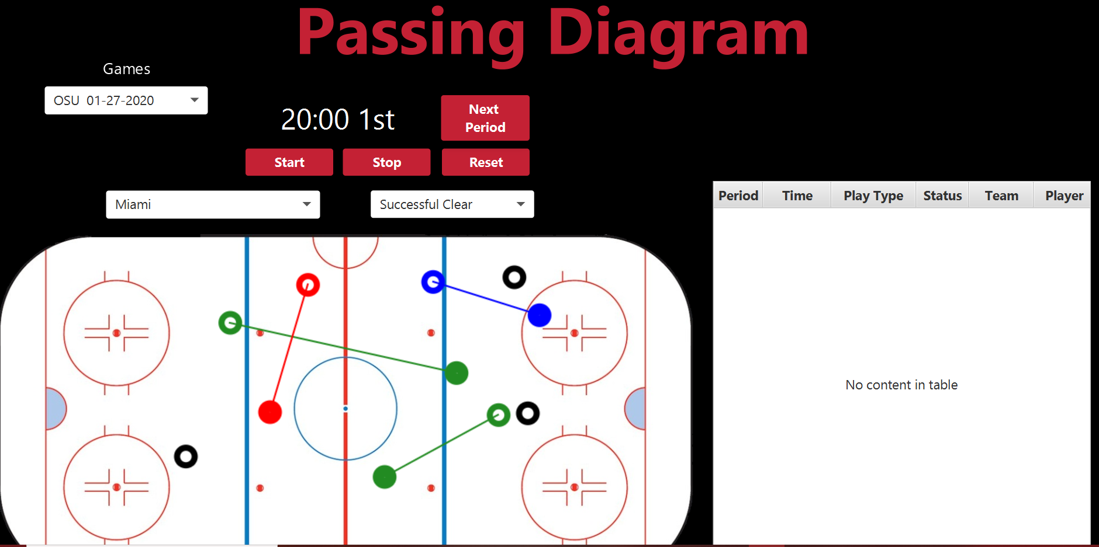

**[5] Time On Ice**

